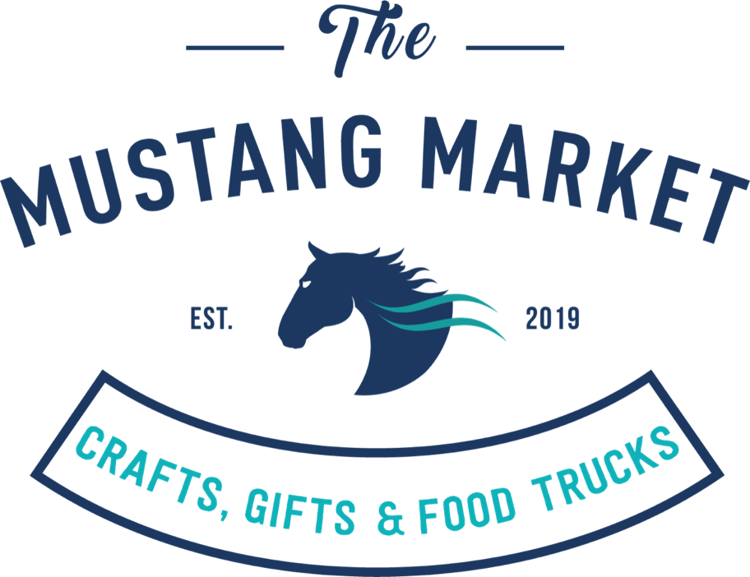

Updated October 6, 2019

Ahimsa Vibe LLC | Ashley Burgess
Avy's Handmade Gifts | Avy Kahat
Azelle LLC | Vedika Krishna
Barleigh's | Barbara Weir/Leigh McIntyre
Be Spiraled | Erin Plummer
BLT Creations | Lauren Gretchen and Nicki Mantzouris
BiDesign & BBS Creations | Valentina Acevedo & Staci Godiva
Camilla Jane Crafts | Camilla Samoryk
Card Art | Monica Revelle
Carol's Custom Creations | Carol
Catonsville Coastin | Mary Ann Simmons
Ceramic Coasters | Mary Hatfield
Cherapy | Claudia Phillips
Chesapeake Bay Creations | Sunhild D. Bolander
Coco Couture | Jessica Zaleskiwice
Color Street: Love your Nails with Kristen | Kristen Dargis
Cozaana - unique silver work | Carlos Zepeda
Crafts by Adele | Adele Josiger
Creative Crochet by Inge | Inge Hyde & Maria Young
CT Creations | Carolyn Snowden
Damsel in Defense | Tiara Kelly
elan Indique - Accessories | Neerja Kathuria
Eva's Porcelain Dolls, plus | Eva Watson
Fadder's Treasurer | Thomas Schiaffino
Fairland Books | Ellen Nibali
Gem Creations | Bonnie Peterson
Glistening Glassworks | Marion Insley
Highly Creative | Rosemary Barnes
Holly Oak Antiques and Gifts | Chuck Boughan and Frank Beckman
Hong's Crafts | Ms. Hong
It's the Small Things | Sarah Braswell
Jay's Condiments | Jayati Sarkar
Karleen's Kreations | Karleen Leasure
Kinver Edge Pinnies | Patricia Dreja
Larwood Glass | Deborah Larwood
Lisa Reynolds Crafty Hands | Lisa Reynolds
Lula Roe | Debbie Davis
M&M Creations - Paper Crafts | Ann King
Magnolia and Vine | Ganine
Magnor Handcrafted Products | Maggie R. Sands
Mary Kay Cosmetics | Patricia Mathurin
Merriment Crafts | Meredith Worthington
Norwex | Patty Roberts
Paparazzi Jewelry | Tara Lemon
Pashion for Fashion | Shannon Bacote
Peacock Proud Design | Susan Davenport
Phable a Thable | Carolina Musters
Premier Designs - Your Favorite Jewelry Lady | Julia Bondar
Quilts Etc. By Anne, LLC. | Anne Rhodes
Reclaimed by You | Craig Newcomb
Resinating Woodwork | Amy Rouk
Rodan and Fields | Terri Fenlon
Sarah's Crafts | Sarah Irby
Savon Amour Naturals | Nailah Welch
Say it Simply Vinyl Design and Decor | Robin Bloch
Scentsy | Kellee Gonzalez
Science Olympiad Student Club | MRHS Student Group
Serving Up Sparkles | Kathy McMillan
Shea by QuizzyMae | Quizzina Forney
Simply Turned | Dan Luttrell
Soho Loft Jewelry | Kathy Fremuth
Spider Lady | Andrea Swangler
Stained Glass your Way, Eclectic Electric CBG | Sharon Yetter and Brian Long
Stick-It-To-Me! Pin Cushions | Pat Moore
Sugar Crush Sweet Treats | Nina Cox
Tastefully Simple | Elisha Bryant
The Golden Stitch | Nadia Baxter
The Wineing Twins | Christina Appleman, Giana Preuss
Thirty - one, bags | Susan Ashman
Trish Doty: Brush, Water & Color | Trish Doty
Tupperware | Jessica Mills
V's Food Truck | Vinny D.
Variety Plus | Shelia Ressler
Vicky's Craftroom | Vicky l. Luttrell

